34.10: For a convex mirror, 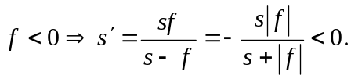 Therefore the image is always virtual. Also 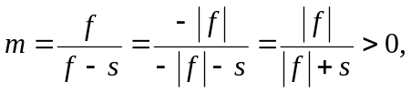so the image is erect, and 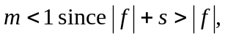so the image is smaller.

